Published by | Editor

HEWI
Marketing + Innovation

HEWI Heinrich Wilke GmbH
P.O. box 1260
D-34442 Bad Arolsen
Phone: +49 5691 82-0
presse@hewi.de
www.hewi.com

Reprint free - specimen copy requested

Classic Meets Newcomer
New cabinet furniture
The design office etage8 brings a breath of fresh air into the HEWI furniture hardware collection and casts the classic products in a new light.
The new practical drawer and door opener are available in various designs. Recessed handles, handles and knobs with matt and glossy surfaces are available to choose from.
In addition to the surface, colour also becomes a design element here. The products are available in all HEWI colours, and the black, white or grey tones can be blended discreetly into the room design or become an eye-catcher in brighter colours.
The design office etage8 has experience in the healthcare field, Industry 4.0 and universal design – best prerequisites for a cooperation with HEWI.

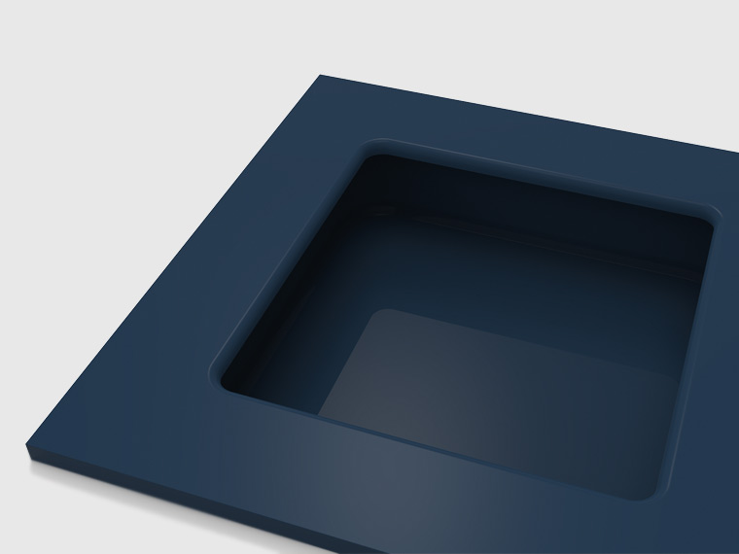
New cabinet furniture

